Priston Parking

Context
In recent times it has become clear that there are more vehicles in Priston than there used to be, whereas the available space for parking has remained approximately the same for a number of years.

There are some parts of the village – especially but not only along the High Street – where parking spaces are hard to find close to people’s homes.

At the same time cars have become wider, yet the roads are the same width. Visibility and “passability” especially for wide vehicles such as farm and emergency vehicles has become an issue on occasion.

The underlying factors for the increase in vehicle numbers reflect long term shifts in the nature of the village. There are more people living alone. There are more households with teenagers. There are fewer buses. More people work from home for part of the time. There are more houses.

At the same time some of the available parking spaces in houses or driveways have either fallen out of use or become inaccessible.

And lastly it seems that we have more visitors to the village – Airbnb, shoot days, commuters, weddings etc etc.

The net result seems to be that there are more vehicles trying to park on the street.

Review
The Parish Council has undertaken to review and understand the pressure on parking spaces during 2026. Although it is clear that there is an issue, what isn’t clear is how much of an issue this really is. Our first step is to understand how many cars there are in the village compared to the number of available parking spots. It could be that a simple rethink of where cars are parked may solve many of the issues – but until we have a clear idea on numbers of vehicles and spaces for parking it is hard to assess.

We have therefore designed a short questionnaire to try and collect the statistics related to vehicles, locations and parking spaces available. Once we have gathered the information required to get a better understanding of the issue we plan to hold a meeting to discuss and review potential solutions.

Priston Parking Questionnaire
The returned Questionnaires will only be viewed by members of the Parish Council and any results published will be aggregated and anonymised using the data supplied.

1: Location

Please mark on this map where in the village you live. We are especially interested in the areas which have on street parking and are tight for spaces. Put a cross or a dot.

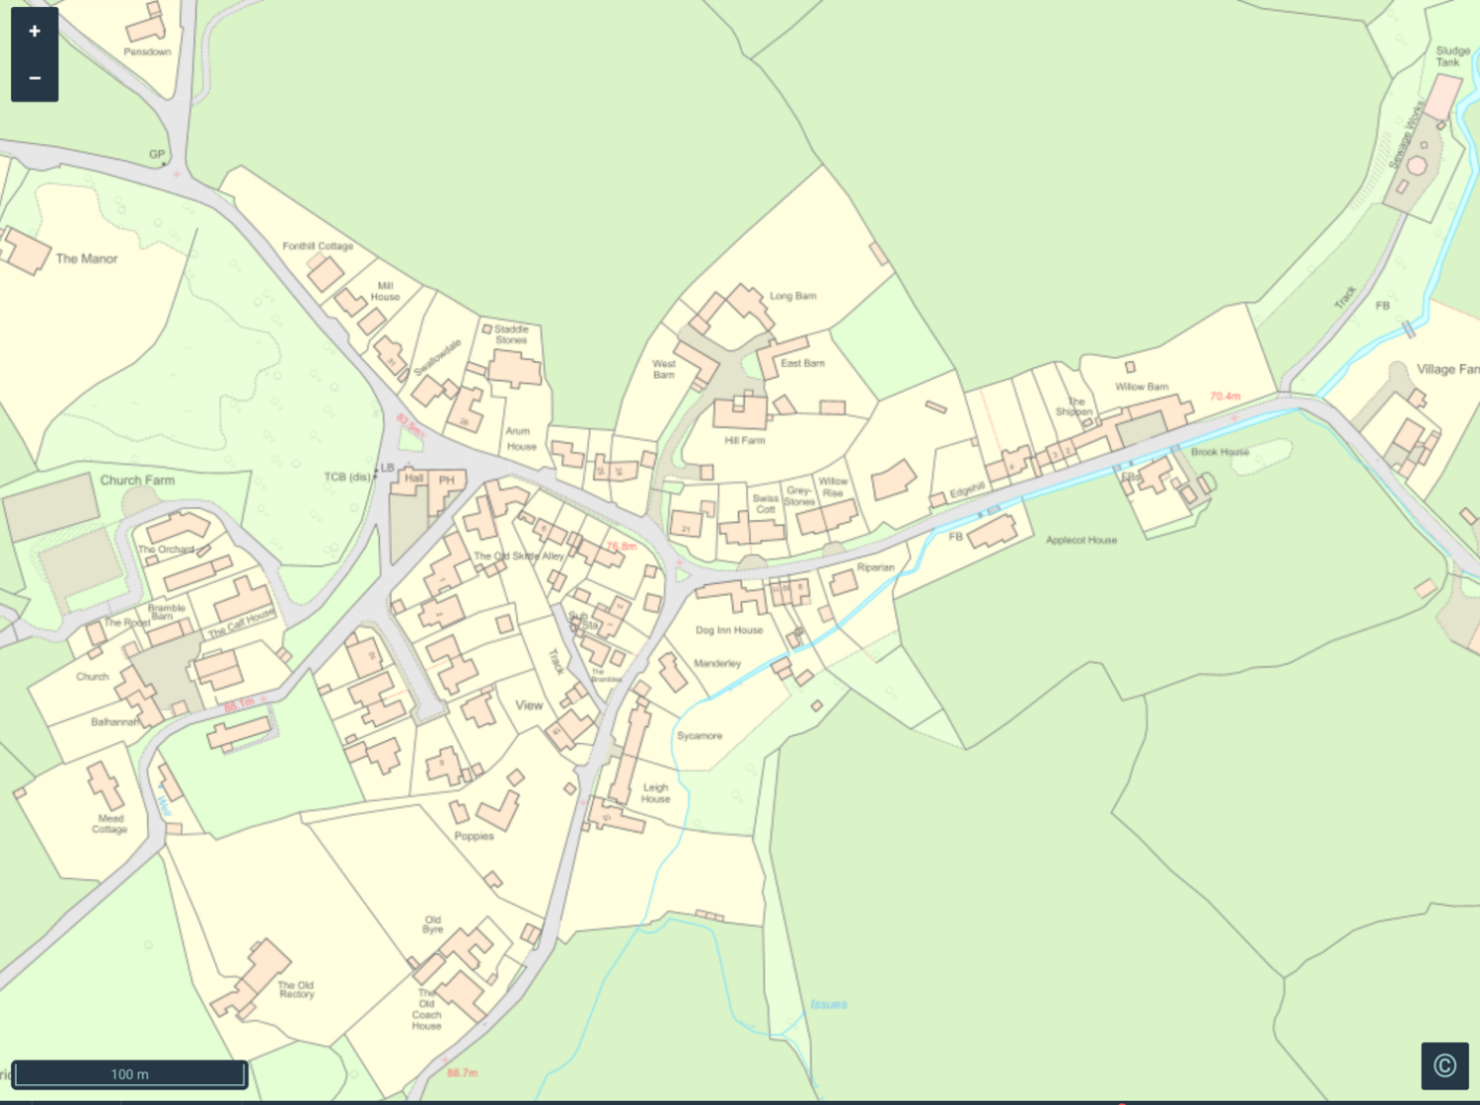

2. How many Vehicles

How many vehicles do you have today (2026)?

How many did you have 3 years ago?

How many will you have in 3 years time?

3. Do you have need for additional parking beyond your own Vehicles?

Do you have visitors to your property? (Family, Friends, Airbnb etc)

- How often roughly?..…………………………………………………………………….……………………….

- How many vehicles?...………………………………..………………………………….………………………

- Where do they park?..…..……………………………………………………………………………………….

4. Day/night parking:

When do you need to park your vehicles?

- Just in the day

- All day and all night

- Mostly at night

- It varies every day

5. Off street parking access:

Parking spaces:

Do you have a parking space/s on your property?

- How many?

- Are they accessible at present?

- Are they in use?

    - Some of the time

    - All of the time

    - None of the time

Would it be possible to create a new parking space on your near your property? (please provide details)

6. On Street parking access

Do you park on the street?

How many of your vehicles do you park on the street?

For all the vehicles on the street, how close to your home do you park most days?
(Please tell us if you park cars in multiple locations)

8. Village Hall and other parking areas

Do you have use of the Village Hall car park

How many of your vehicles do you park there?

Do you have use of other parking areas in the village? Can you let us know where and how many vehicles are parked there?

7. Important other parking information

Do you have access challenges to your home

(e.g. do you have small kids and buggies)?

Do you have mobility issues?

8. General comments:

Please use this space to detail specific issues or challenges you encounter with parking.
If you have any specific suggestions please put them in here and overleaf/on the back of this page.

What happens next?

Your Parish Councillor will collect this form on or before Saturday 28th March 2026. Alternatively, please email the completed form to parishclerk@priston.org.uk by Monday 6th April.

The data will be collated and analysed (responses will be kept anonymous) before being discussed at the next Parish Council meeting on 11th May 2026

Any ideas or proposals to ease the parking situation will then be refined and shared. Our expectation is that most of the problems and challenges can be solved as a community. But if we need additional support from BANES we will enlist their support and advice as appropriate. .

Priston Parish Council
March 2026

